Teaching Practice Action Plan
Shared:

Current teaching practices that I am working on is:

(copy from Needs Assessment)
I will:

(description of teaching practice during implementation/what will it look like?)
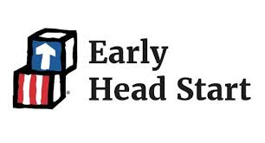
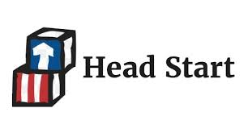
Tri-County Head Start/Early Head Start
Steps to achieve my goal… | Resources needed: | By when:
Coach Signature: | Coachee’s Signature: | Date:
Date of Review: ___________ Coach Initials: __________ Coachee’s Initials: ________
I have achieved this goal by successfully completing the steps specified in the goal achievement step(s) above. | I am making progress towards my goal and will continue to implement and practice my action steps. | I need to make changes to my plan to help me achieve my goal by revising the goal/steps.
O Approaches to Learning O Social Emotional O Language Communication O Cognition O Perceptual, Motor, and Physical Development
O CLASS O Curriculum Fidelity O Conscious Discipline O Al’s Pals

